ASSIGNMENT-13.4

2303A51852
Task 1: Refactoring Data Transformation Logic
Task Description
- Review the legacy code that computes transformed values using an explicit loop.
- Use an AI tool to suggest a more Pythonic refactoring approach.
- Refactor the code using list comprehensions or helper functions while preserving the output.
PROMPT:
Refactor the following Python code to make it shorter and more Pythonic using list comprehension while keeping the same output.
values = [2, 4, 6, 8, 10] doubled = []
for v in values:
doubled.append(v * 2) print(doubled)
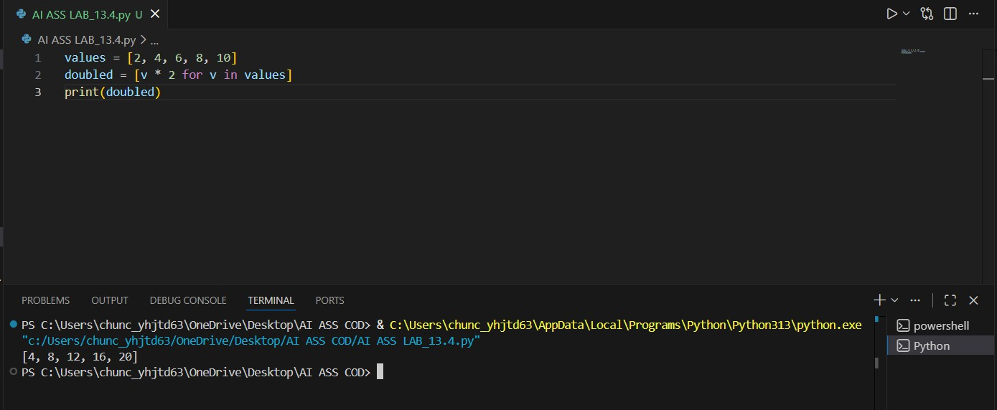
Task 2: Improving Text Processing Code Readability
- Analyze the legacy code that constructs a sentence using repeated string concatenation.
- Ask AI to suggest a more efficient and readable approach.
- Refactor the code accordingly while k

eeping the final output unchanged.

PROMPT:
Refactor the following Python code to improve readability and efficiency by avoiding repeated string concatenation. Keep the same output.

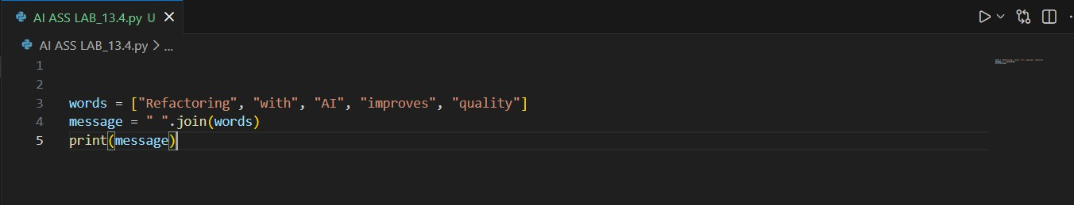
OUTPUT:
Task 3: Safer Access to Configuration Data
- Review the legacy code that manually checks for dictionary keys.
- Use AI suggestions to refactor the code using safer dictionary access methods.
- Ensure the behavior remains the same for missing keys.
PROMPT:
Refactor the following Python code to use a safer dictionary access method instead of manually checking keys. Keep the same output if the key is missing.
config = {"host": "localhost", "port": 8080} if "timeout" in config:
print(config["timeout"]) else:
print("Default timeout used")
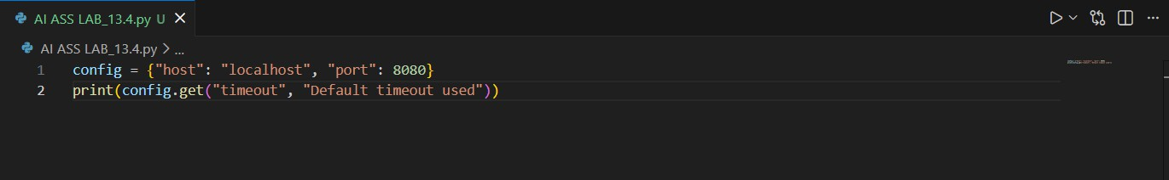

OUTPUT:

Task 4: Refactoring Conditional Logic for
Scalability
Examine the multiple if–elif conditions used to determine operations.
Ask AI to suggest a cleaner, scalable alternative.
Refactor the logic using mapping techniques while preserving functionality.

PROMPT:
Refactor the following Python code to replace multiple if–elif conditions with a cleaner and scalable mapping approach while keeping the same output.

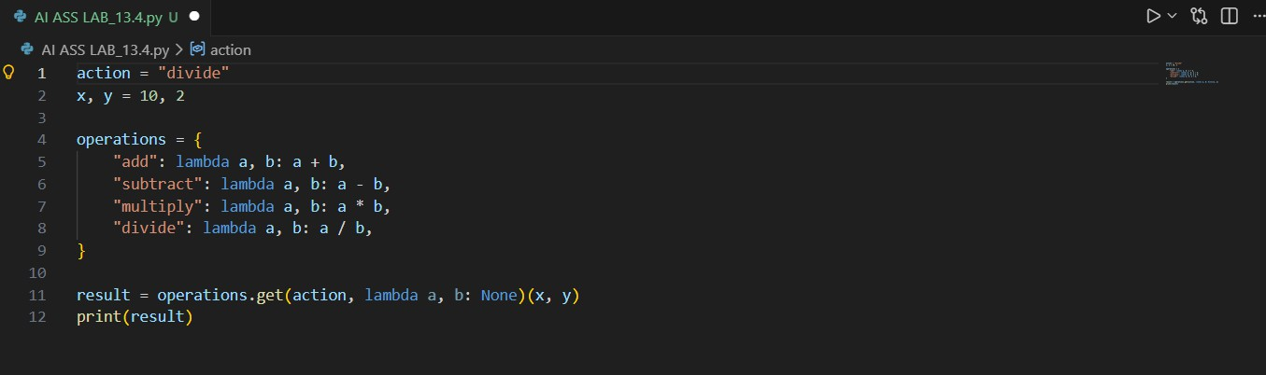

OUTPUT:

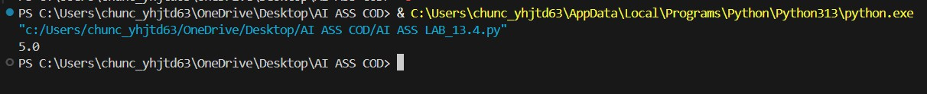
Task 5: Simplifying Search Logic in Collections
Identify the explicit loop used for searching an item.
Use AI assistance to refactor the logic into a more concise and readable form.
Maintain the same output behavior.

PROMPT:
Refactor the following Python code to simplify the search logic in a collection using a more concise Python approach while keeping the same output.

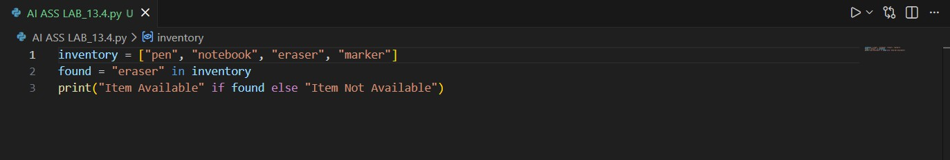

OUTPUT:

